**Assignment 1**

1. What is JDK? JRE? JVM?
   * JRE: is the JVM program, Java application need to run on JRE.
   * JDK: contains the tools for developing Java programs running on JRE, for example, it provides the compiler “javac”.
   * JVM: the Java Virtual Machine (JVM) is an abstract computing machine. The JVM is a program that looks like a machine to the programs written to execute in it.
2. What is java compiler?
   * A Java compiler is a program that takes the text file work of a developer and compiles it into a platform-independent Java file. For example, Java Programming Language Compiler(javac)
3. Why is java platform independent?
   * Java is platform-independent because it uses a virtual machine. The Java programming language and all APIs are compiled into bytecodes. Bytecodes are effectively platform-independent. The virtual machine takes care of the differences between the bytecodes for the different platforms.
   * The run-time requirements for Java are therefore very small. The Java virtual machine takes care of all hardware-related issues, so that no code has to be compiled for different hardware.
4. What is IDE? Why is it important for developers?
   * An integrated development environment (IDE) is software for building applications that combines common developer tools into a single graphical user interface (GUI).
   * IDEs increase programmer productivity by combining common activities of writing software into a single application: editing source code, building executables, and debugging.
5. Is java case sensitive?
   * Yes, Java is a case-sensitive language, which means that the upper or lower case of letters in your Java programs matter.
6. What do the following key words do?  
   static, final, public, private, void, null, package, Class, new
   * static: Attributes and methods belongs to the class, rather than an object
   * final: Attributes and methods cannot be overridden or modified.
   * public: The access level of a public modifier is everywhere. It can be accessed from within the class, outside the class, within the package and outside the package.
   * private: The access level of a private modifier is only within the class. It cannot be accessed from outside the class.
   * void: The void keyword specifies that a method should not have a return value.
   * null: null is a reserved word for literal values. It seems like a keyword, but actually, it is a literal similar to true and false.
   * package: The package keyword creates a package.
   * class: The class keyword is used to create a class. A class should always start with an uppercase first letter, and the name of the java file must match the class name.
   * new: Used to create an instance of the class. In other words, it instantiates a class by allocating memory for a new object and returning a reference to that memory. We can also use the new keyword to create the array object.
7. What is primitive type and reference type?
   * The primitive types are boolean, byte, char, short, int, long, float and double. All other types are reference types, so classes, which specify the types of objects, are reference types.
8. Is parameter passed by value or reference?
   * Java always passes parameter variables by value.
   * Object variables in Java always point to the real object in the memory heap.
   * A mutable object’s value can be changed when it is passed to a method.
   * An immutable object’s value cannot be changed, even if it is passed a new value.
9. What is the output: System.out.println(1 > 0 : “A”:”B”);
   * error: ')' expected
   * if the statement is System.out.println(1 > 0 ? “A”:”B”);, then output would be "A"
10. How to define constants in java?
    * (public/private) (static) final TYPE NAME = VALUE;
11. What is String? Is it primitive type?
    * In Java, string is basically an object that represents sequence of char values. An array of characters works same as Java string.
    * String is **not** a primitive data type. Java.lang package provides the String class therefore, it is an object type.
12. How to check if a String is representing a number?
    * Integer.parseInt()
    * Integer.valueOf()
    * Double.parseDouble()
    * Float.parseFloat()
    * Long.parseLong()
    * Use regular expressions
13. Write a program to implement the following activity diagram:

|  |
| --- |
| import java.text.SimpleDateFormat; import java.util.Date; import java.util.Scanner; public class Assignment1Q13 {  public static void main(String[] args) {  Scanner keyboard = new Scanner(System.in);  System.out.print("enter an integer: ");  while(keyboard.hasNext()) {   try {  if (keyboard.hasNextInt()) {  int input = keyboard.nextInt();  // System.out.println("You entered: " + input);  if (input > 0) {  doSomething(input);  } else {  System.out.println("Error: invalid input number.");  }  } else {  if (keyboard.next().equals("q")) {  return;  }  }  System.out.print("enter an integer: ");  } catch (Exception e) {  System.out.println(e.getMessage());  System.out.println(e.fillInStackTrace());  return;  }  }  }   private static void doSomething(int x) {  int res = 0;  for (int i = 1; i <= x; i++) {  res += i;  }  System.out.println("sum from 1 to " + x + " is: " + res);  SimpleDateFormat formatter = new SimpleDateFormat("dd/MM/yyyy HH:mm:ss z");  Date date = new Date();  System.out.println(formatter.format(date));  } } |
|  |

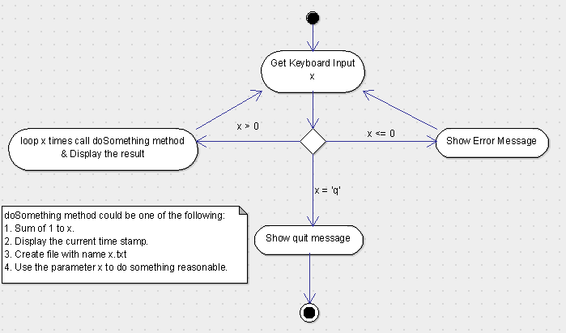

1. Write a program to merge two array of int.

|  |
| --- |
| public static int[] merge(int[] a, int[] b) {  Arrays.sort(a);  Arrays.sort(b);  int[] res = new int[a.length + b.length];  int ap = 0, bp = 0, resp = 0;  while (ap < a.length && bp < b.length) {  if (a[ap] < b[bp]) {  res[resp++] = a[ap++];  } else {  res[resp++] = b[bp++];  }  }  if (ap < a.length) {  while (ap < a.length) {  res[resp++] = a[ap++];  }  }  if (bp < b.length) {  while (bp < b.length) {  res[resp++] = b[bp++];  }  } } |

1. Write a program to find the second largest number inside an array of int.

|  |
| --- |
| private static int secondLargest(int[] array) {  Arrays.sort(array);  return array[array.length - 2]; } |